Chapter 15, Solution 42.

Design a problem to help other students to better understand how to convolve two functions together.

Although there are many ways to solve this problem, this is an example based on the same kind of problem asked in the third edition.

Problem

Suppose that f(t) = u(t) – u(t-2). Determine f(t)*f(t).

Solution

For 0<t<2, the signals overlap as shown below.

1

t-2 0 t 2 λ

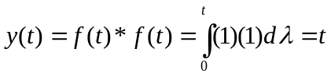
For 2 < t< 4, they overlap as shown below.

1

0 t-2 2 t λ

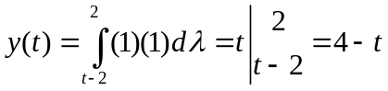

Thus,
